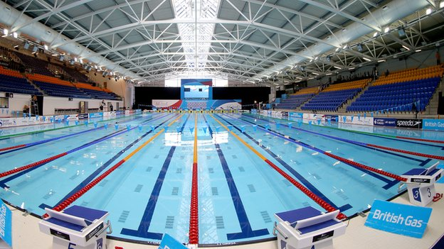
Glasgow International
Swim Meet

25th -27th May 2018

Tollcross International Swimming Centre

Glasgow, Scotland

(Held under FINA Rules/Scottish Swimming Regulations)

Hosted by:
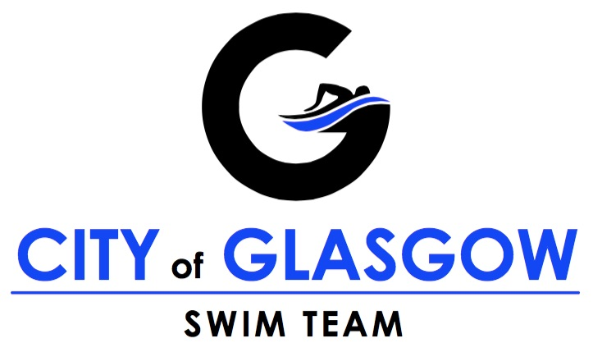

In partnership with:

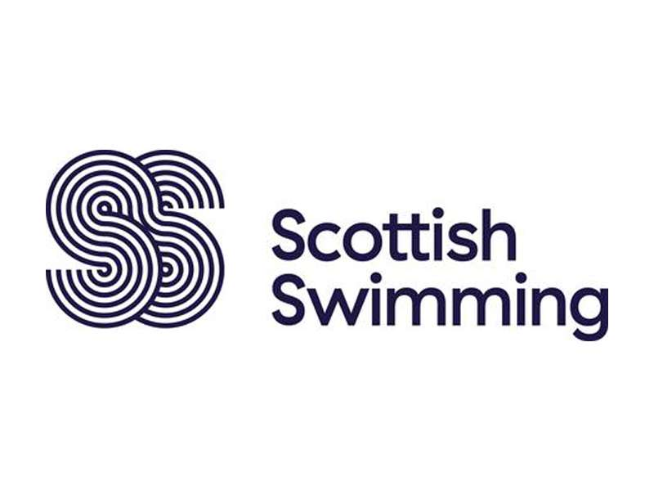

Supported by:

Licence: L1/572/SS/MAY18 #GISM18

GLASGOW INTERNATIONAL SWIM MEET 2018
(Held under FINA Rules/Scottish Swimming Regulations)
Dates: Friday 25th May – Sunday 27th May 2018
Venue: Tollcross International Swimming Centre, Glasgow
Pool: 10 lane x 50 metre with separate 4 lane x 25 metre warm-up and swim-down facility
Meet Promoter: City of Glasgow Swim Team (COGST)
Licence Number: L1/572/SS/MAY18

OUR MISSION
To deliver an annual international standard open long course swimming competition that is ideally placed in the UK and European calendar and attractive to regional, national and overseas athletes/clubs/teams. To showcase Glasgow as a city of sport, culture and education, with world-class swimming facilities and a club based training environment that supports a nation-leading programme.

OBJECTIVES
- Put competitors (and their clubs/teams) first – this meet’s primary purpose is for them to perform to their best. Do everything we can to ensure the athlete experience is world-class.
- Deliver a great event that athletes from Scotland, the UK and around the world want to come back to year after year.
- Put/keep Glasgow on the international swimming map – meets, venues, programmes, universities, culture.
- Event management, organisation, safety and security are of the highest standard given the resources available.
- The profile of Glasgow as a place to live, study, work and swim is raised.
- There is an opportunity for volunteer support and engagement.
- Be spectator and athlete/team staff friendly.
KEY PERSONNEL AND CONTACT INFORMATION
Meet Website: www.glasgowswimmeet.com
General Email Enquiries: info@glasgowswimmeet.com
General Phone Enquiries: Ian Wright – 07956 881833
Email for Entries: brian@swimglasgow.co.uk
Facility Address: Tollcross International Swimming Centre, 350 Wellshot Road, Glasgow, G32 7QP
Meet Director: Liz Stewart
Assistant Meet Director: Alison Finlayson
Meet Referee: Janice Morgan
Field of Play Manager: Alan Fletcher
Entries Secretaries: Brian McQueenie & John Deans
Recorder: Stewart Finlayson
AOE Team: Ian Fleming, Joyce Fleming, Sean Dawson
VIP Manager: Karen Gray
STO Manager: Jean King

GENERAL INFORMATION
Eligibility to Compete
All competitors must be registered with their National Federation to be eligible to compete (FINA Rule GR 1.1).

Anti-Doping Testing
Please note that anti-doping testing may be in operation at this event.

Swimwear
British Swimming and Scottish Swimming advise that FINA BL 8.1 only applies to Olympic Games and FINA events. A suit check will only be made if a World or European record is being claimed. There is no requirement for officials to check that costumes are on the approved FINA list. Bylaws BL 8.2 and BL 8.3 cover the requirements for design and material.

MEET SCHEDULE AND CONSIDERATION TIMES

Friday 25th May 2018 |  | Saturday 26th May 2018 |  | Sunday 27th May 2018
Session 1 – Fastest Heats |  | Session 4 – Fastest Heats |  | Session 7 – Fastest Heats
Warm-up: 08:00 Start: 09:05 Finish: 11:10 |  | Warm-up: 08:00 Start: 09:05 Finish: 11:10 |  | Warm-up: 08:00 Start: 09:05 Finish: 11:10
Event | CT* | Event | CT* | Event | CT*
Women’s 200m IM | 2:35.89 | Women’s 400m IM | 5:31.98 | Women’s 50m Butterfly | 0:32.55
Men’s 200m IM | 2:28.51 | Men’s 400m IM | 5:12.80 | Men’s 50m Butterfly | 0:29.39
Women’s 100m Butterfly | 1:14.11 | Women’s 200m Freestyle | 2:20.49 | Women’s 400m Freestyle | 4:51.02
Men’s 100m Butterfly | 1:05.72 | Men’s 200m Freestyle | 2:09.66 | Men’s 400m Freestyle | 4:36.01
Women’s 200m Backstroke | 2:36.98 | Women’s 100m Breaststroke | 1:25.65 | Women’s 100m Backstroke | 1:12.49
Men’s 200m Backstroke | 2:31.44 | Men’s 100m Breaststroke | 1:18.24 | Men’s 100m Backstroke | 1:08.36
Women’s 50m Freestyle | 0:30.13 | Women’s 200m Butterfly | 2:49.74 | Women’s 200m Breaststroke | 3:04.84
Men’s 50m Freestyle | 0:27.23 | Men’s 200m Butterfly | 2:34.95 | Men’s 200m Breaststroke | 2:49.81
Women’s 50m Breaststroke | 0:39.71 | Women’s 50m Backstroke | 0:34.69 | Women’s 100m Freestyle | 1:03.65
Men’s 50m Breaststroke | 0:35.39 | Men’s 50m Backstroke | 0:32.46 | Men’s 100m Freestyle | 0:58.44
Session 2 – Remaining Heats |  | Session 5 – Remaining Heats |  | Session 8 – Remaining Heats
Warm-up: 11:15 Start: 12:15 Finish: 15:15 |  | Warm-up: 11:15 Start: 12:15 Finish: 15:15 |  | Warm-up: 11:15 Start: 12:15 Finish: 15:15
Women’s 200m IM | 2:35.89 | Women’s 400m IM | 5:31.98 | Women’s 50m Butterfly | 0:32.55
Men’s 200m IM | 2:28.51 | Men’s 400m IM | 5:12.80 | Men’s 50m Butterfly | 0:29.39
Women’s 100m Butterfly | 1:14.11 | Women’s 200m Freestyle | 2:20.49 | Women’s 400m Freestyle | 4:51.02
Men’s 100m Butterfly | 1:05.72 | Men’s 200m Freestyle | 2:09.66 | Men’s 400m Freestyle | 4:36.01
Women’s 200m Backstroke | 2:36.98 | Women’s 100m Breaststroke | 1:25.65 | Women’s 100m Backstroke | 1:12.49
Men’s 200m Backstroke | 2:31.44 | Men’s 100m Breaststroke | 1:1824 | Men’s 100m Backstroke | 1:08.36
Women’s 50m Freestyle | 0:30.13 | Women’s 200m Butterfly | 2:49.74 | Women’s 200m Breaststroke | 3:04.84
Men’s 50m Freestyle | 0:27.23 | Men’s 200m Butterfly | 2:34.95 | Men’s 200m Breaststroke | 2:49.81
Women’s 50m Breaststroke | 0:39.71 | Women’s 50m Backstroke | 0:34.69 | Women’s 100m Freestyle | 1:03.65
Men’s 50m Breaststroke | 0:35.39 | Men’s 50m Backstroke | 0:32.46 | Men’s 100m Freestyle | 0:58.44
Men’s 1500m Freestyle  (HDW) – 3 heats | 18:26.59 | Women’s 800m Freestyle  (HDW) – 3 heats | 9:57.27 | Women’s 1500m Freestyle (HDW) – 1 heat | 18:34.94
 |  |  |  | Men’s 800m Freestyle  (HDW) – 1 heat | 8:54.21
Session 3 – FINALS |  | Session 6 – FINALS |  | Session 9 – FINALS
Warm-up: 16:00 Start: 17:15 Finish: 19:35 |  | Warm-up: 16:00 Start: 17:15 Finish: 19:45 |  | Warm-up: 15:45 Start: 16:45 Finish: 19:05
Fastest heat of Men’s 1500m Freestyle |  | Fastest heat of Women’s 800m Freestyle |  | C-B-A Finals of Women’s 50m Butterfly
C-B-A Finals of Women’s 200m IM |  | C-B-A Finals of Men’s 400m IM |  | C-B-A Finals of Men’s 50m Butterfly
C-B-A Finals of Men’s 200m IM |  | C-B-A Finals of Women’s 400m IM |  | C-B-A Finals of Women’s 400m Freestyle
C-B-A Finals of Women’s 100m Butterfly |  | C-B-A Finals of Men’s 200m Freestyle |  | C-B-A Finals of Men’s 400m Freestyle
C-B-A Finals of Men’s 100m Butterfly |  | C-B-A Finals of Women’s 200m Freestyle |  | C-B-A Finals of Women’s 100m Backstroke
C-B-A Finals of Women’s 200m Backstroke |  | C-B-A Finals of Men’s 100m Breaststroke |  | C-B-A Finals of Men’s 100m Backstroke
C-B-A Finals of Men’s 200m Backstroke |  | C-B-A Finals of Women’s 100m Breaststroke |  | C-B-A Finals of Women’s 200m Breaststroke
C-B-A Finals of Women’s 50m Freestyle |  | C-B-A Finals of Men’s 200m Butterfly |  | C-B-A Finals of Men’s 200m Breaststroke
C-B-A Finals of Men’s 50m Freestyle |  | C-B-A Finals of Women’s 200m Butterfly |  | C-B-A Finals of Women’s 100m Freestyle
C-B-A Finals of Women’s 50m Breaststroke |  | C-B-A Finals of Men’s 50m Backstroke |  | C-B-A Finals of Men’s 100m Freestyle
C-B-A Finals of Men’s 50m Breaststroke |  | C-B-A Finals of Women’s 50m Backstroke

- CT = Long Course Consideration Time. Swimmers must have achieved this time in an accredited long course meet (or the equivalent converted short course time) in order to enter.
- Warm-up and session times may be adjusted once all entries have been received and processed. Any changes to times will be notified when the draft programme is issued.
- HDW = Heat Declared Winner events

COMPETITION RULES
- All ten lanes will be used for heats and finals.
- The top ten swimmers (regardless of age) from the heats of each event (except HDW events) shall progress to the ‘A’ final.
- The next ten swimmers (regardless of age) from the heats of each event shall progress to the ‘B’ final.
- The ‘C’ final shall be a ‘Junior’ final consisting of the next ten fastest swimmers from the heats aged 17/under (for males) and 16/under (for females) – all ages as at 31st December 2018.
- Finals for each event will be swum in C-B-A order.
- On each day, the fastest heats of each event shall be swum first, followed by all remaining heats of each event. The number of fastest heats swimming first shall be as follows: 50m events = six; 100m & 200m events = five; 200m butterfly and 400m events = three.
- The fastest three heats of 50m, 100m and 200m events and the fastest two heats of 400m events shall be cyclic seeded. All other heats will be spearheaded in time order.
- The Women’s 800m and Men’s 1500m Freestyle distance events shall be swam as Heat Declared Winner and limited to a maximum number of four heats with the fastest of those heats swimming during the respective finals session. The Men’s 800m Freestyle and Women’s 1500m Freestyle will be Heat Declared Winner with one heat of each racing in the Day 3 afternoon heats sessions.
Should the number of entries result in a combined heats session time of four hours or less on each or all days of the competition, the organisers reserve the right to alter the heats sessions at the time of the draft programme being issued, and swim them as one session. In this scenario, the slower heats will commence immediately after the faster heats have finished. If the meet is not full, the organisers reserve the right to adjust the placement of the freestyle distance events should doing so be deemed beneficial to the running of the meet.

ENTRIES
Individual Events: £10.00
All payments must be made by electronic BACS transfer to the following account:
Account Name: Glasgow International Swim Meet Sort Code: 80-07-78 Account Number: 10117963
Please use the reference GISM and your Club Name when making all entry fee transfers.
No entries will be accepted without the correct fee, or with the entry files incorrectly completed. Entry fees will not be refunded for any times submitted out-with the consideration time. No refunds will be given after the programme has been finalised.
Competitors must enter times achieved in accredited competitions held since 1st January 2015 and either be 50 metre pool times or conversions to 50 metre pool times (Official conversion tables: Hy-tek standard conversion or ASA conversion tables may be used).
A proof of entry times report is required with entry. Random checks on entry times will be carried out prior to and during the event. Any swimmers submitting an unaccredited entry time will be withdrawn from that event and will forfeit their entry fee.
The organisers reserve the right to restrict entries to ensure session times are met and the overall smooth running of the meet. If it is necessary to reject entries, this will be done on the basis of entry time, slowest to fastest.

Making Entries – Phase 1
All entries must be made using Hy-tek Team Manager files. The entry file will be posted on the meet website, on www.swimscotland.org.uk and www.swimglasgow.co.uk - and it can also be requested by emailing brian@swimglasgow.co.uk
The closing date for receipt of Phase 1 entries is 18:00 BST, Tuesday 8th May 2018
The entry files and other required paperwork must be emailed to brian@swimglasgow.co.uk
There will be no entries by post.
All payments must be received within three days of the entry closing date – i.e. by 18:00 BST, Friday 11th May 2018.
Please ensure that you request an email read receipt, if you wish confirmation of entries being received.
The entry summary sheet (found in the entry pack) and proof of entry time report should be returned by email with the entry file.
A draft programme will be issued to teams by Monday 14th May.

Making Entries – Phase 2
Clubs will be advised by Monday 14th May if any spaces are remaining. If the meet is not full, additional entries may be accepted until Friday 18th May. These entries must still meet the event Consideration Time and will be accepted on time basis (fastest to slowest). Phase 2 entries will not be eligible for the fastest heats sessions and will all be allocated where space remains in the slower heats sessions. Any such entries will cost £10 and must be made in the same way (i.e. via Hy-tek file) or by submission of a spreadsheet (available in the entry pack). The programme will then be finalised and posted online.

Reserves
Up to five reserves for the heats of each event may be allocated at the absolute discretion or the organisers. City of Glasgow Swim Team also reserves the right to fill any remaining lanes/spaces in the meet with additional City of Glasgow Swim Team swimmers. Reserve swimmers may be slotted into morning or afternoon heats depending on swimmer and lane space availability.

Hy-Tek Team Manager Lite
For those clubs/teams who do not have a full copy of Hy-Tek Team Manager, the link to the Hy-Tek website for Team Manager Lite is: http://www.hy-tekltd.com/downloads.html Select Team Manager, then Lite

WITHDRAWALS

Withdrawals from Heats
Swimmers withdrawing from either heats sessions must do so by 19:00 on the day before the swim using the official withdrawal forms provided during the meet, or in advance by emailing brian@swimglasgow.co.uk
Swimmers are requested to adhere to this deadline in order that accurate start sheets can be produced. Any swimmer needing to withdraw after the deadline must still do so on the relevant form at the Recorders’ Desk. Empty lanes from withdrawals will be offered to any allocated reserves, followed by City of Glasgow Swim Team members where possible, so it is imperative that swimmers who do not intend to take part confirm their absence in advance.

Withdrawals from Finals
Swimmers withdrawing from Finals must do so as soon as possible and no later than 10 minutes after the end of the session in which they have been competing. Any swimmer not wishing to compete in a final should withdraw using the appropriate form at the Recorder’s desk.

Reserves for Finals
Up to the point of 10 minutes after the end of the afternoon (slowest) heats session, meet recorders will allocate each withdrawn place in any final to the next eligible and available swimmer from the heats results. After this point there will be no named reserves and no further changes to the start list for finals. Any withdrawals after this point will result in empty lanes.

AWARDS
Prize money will be awarded to the top three male and top three female individual performances at the meet as recorded in the finals and HDW events only as determined by the FINA points system. The FINA points system used will be that which is used in the version of Hytek Meet Manager under which the meet is operating. A swimmer can only win one of the top individual performance awards.
Prize money will also be awarded to the top three swimmers in each ‘A’ final and HDW event.
Prizes will also be awarded to the top ranked junior swimmer in each event (boys aged 17/under and girls aged 16/under as at 31st December 2018).
There will be no presentation ceremonies – swimmers will be able to collect their awards from the designated Awards Desk following confirmation of the results.

RESULTS SERVICE & LIVE STREAMING
Live results will be made available on meet mobile and full results posted on the GISM and SwimScotland websites. www.swimscotland.co.uk The meet may be live streamed.

ACCREDITATION
All competitors and club/team staff in this meet will be issued with an accreditation pass which will allow them access to the changing village, designated seating areas and poolside. Accreditation passes must be worn and be visible at all times. Competitors should take their accreditation with them to the call room and marshalling areas.

TRAINING PRIOR TO THE COMPETITION
A small number of lanes may be available at Tollcross International Swimming Centre from 15:00 until 20:00 on Thursday 24th May 2018 for pre-meet training. These will be accessible on a first come first served basis and use may be restricted if demand is high. Clubs/Teams are encouraged to make their own booking with venue management should they wish to guarantee additional exclusive space outwith these lanes.

PHOTOGRAPHY & VIDEO
Any person wishing to use digital video and/or photography of any kind must register their device(s) at the meet information desk. Throughout this event the organisers will have authorised personnel taking static photographs and video footage. These images are intended solely for the purpose of promotion of the event and may include live streaming on the internet. Images will be made available to our media partners and uploaded to our website and our social network sites. Should any competitor not wish to be photographed/videoed please complete a form, available from the meet information desk. Anyone wishing their image to be removed from our website must give notice by email to info@glasgowswimmeet.com after which the data will be removed within seven days of receipt of said notification.

ACCOMMODATION
Glasgow has a wide range of hotels located throughout the city although there are only a small number of options within walking distance of the meet venue. Travelling teams are recommended to choose city centre based hotels for ease of access to transport routes and restaurants. Alternatively, the Premier Inn at Cambuslang is a useful option and is within 20 minutes walk of the pool.

TRAVEL & TRANSPORT
Tollcross International Swimming Centre is in the east end of Glasgow, approximately 4 miles from the city centre which is well served by Glasgow Central and Glasgow Queen Street railway stations. The closest local railway station to the venue is Carntyne, approximately 0.7 miles (15 minute walk) north of the pool.
The venue is easily accessible by bus with multiple bus routes to/from the city centre immediately outside the pool on London Road.
Glasgow International Airport is located to the west of the city centre, 13 miles (20 minute drive) from Tollcross. Overseas teams wishing to arrange transfers from Glasgow International Airport to hotels should contact the meet organisers by email at info@glasgowswimmeet.com by Sunday 6th May 2018.

PARKING
Free parking is available at the venue subject to the car park capacity. Further on street parking is available on the residential roads adjacent to the venue.

CATERING FOR OFFICIALS & TEAM STAFF
Meals and refreshments will be provided free of charge for all meet officials. Club coaches/managers/staff may order meals and refreshments using the form provided in the entry pack (available from February 2018).

TECHNICAL OFFICIALS
Technical officials will be organised through assistance from SASA West District. Entering clubs/teams who are based in the West District are requested to assist with provision of technical officials wherever possible. Travelling clubs are also welcome to provide technical official support.
Anyone wishing to officiate should contact: stoconvenor@scotswimwest.co.uk to register their interest.
Guidance on kit, expenses and other requirements is available on request.

SPECTATOR INFORMATION
Spectator tickets will be available to purchase on arrival on each day of the meet.
Heats tickets – Adults £4.00, Concessions £2.00 (this entitles access to both heats sessions)
Finals tickets – Adults £5.00, Concessions £2.50
Food, drinks and other refreshments are available in the café at the venue.

MEET SPONSORS
The Glasgow International Swim Meet is developed in partnership with Glasgow Life, Scottish Swimming and SASA West District. Other meet sponsors will be announced in due course.

MEET RULES, REGULATIONS & CONDITIONS
- Entry and access to this competition is expressly subject to each and all of these regulations and may, where appropriate, also require compliance with the facility provider’s regulations.
- Permission for any person to enter or to remain within the venue notwithstanding possession of any ticket by that person is at the absolute discretion of the venue staff, event stewards, officers of COGST and/or any police officer.
- No guarantee can be given by COGST that the event will take place at a particular time or any particular date and COGST reserves the right to reschedule the event without notice and without any liability for so doing.
- In the event of postponement, cancellation or abandonment of the event, refunds if any, will be made at the absolute discretion of COGST. COGST will have no legal liability to make a refund or to pay any form of consequential or indirect damage such as loss of enjoyment, travel and accommodation costs.
- The following are articles must not be brought into the venue: fireworks, smoke canisters, air horns, flares, any glass items, weapons of any sort. Any person in possession of such items will be refused entry at the absolute discretion of the venue staff, event stewards, officers of COGST and/or any police officer.
- No person may for commercial purposes take photographs or use any video recording equipment inside this event without the express written permission of COGST. The taking of photographs or use of video equipment for non-commercial purposes is permitted subject to compliance with Glasgow Life and Scottish Swimming guidelines.
- The use of mobile phones, cameras and audio/video recording devices is forbidden in the changing village, toilets and shower areas.
- Flash photography is not permitted at any time within the competition pool hall.
- No articles, periodicals, publications, flyers or goods of any nature may be offered either free or for sale by any persons within this event without the express written permission of COGST.
- Any person entering this event must at all times comply with any and all instructions of any venue staff, event stewards, officers of COGST and/or any police officer. Failure to comply within a reasonable time with any such instruction will lead to the person being asked to leave.
- COGST reserves absolutely the right to eject from this event any person failing to comply with each and all of these regulations.
- It shall be the swimmers’ and coaches’ responsibility to acquaint themselves with all of the information contained in this meet information book and information or changes announced at the Technical Meeting.

