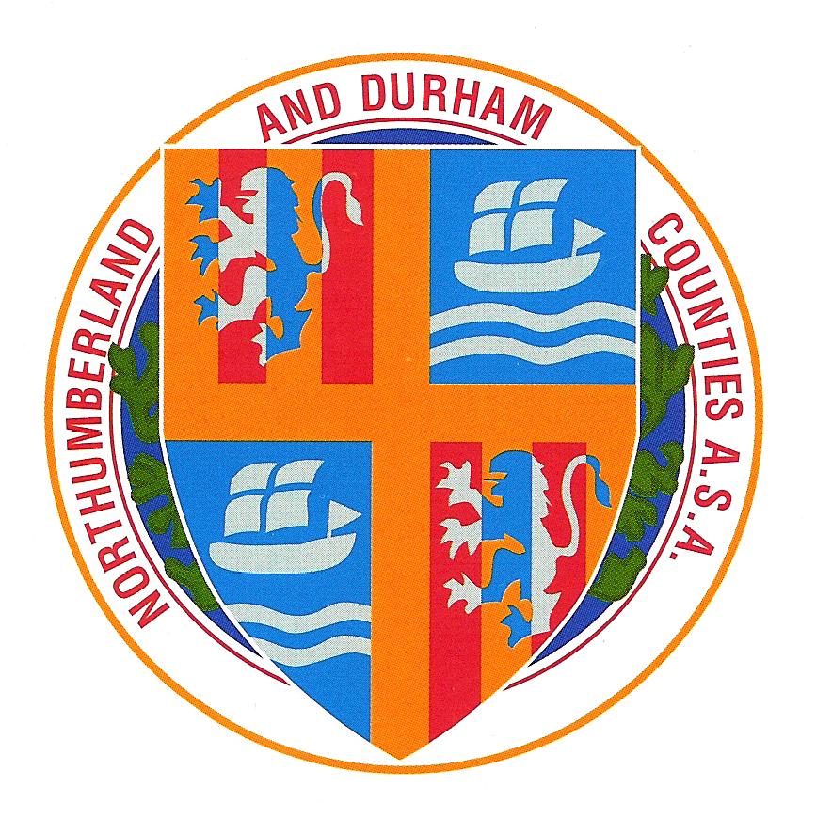

Northumberland & Durham Swimming

Association

Autumn Meet 2013

[under asa Laws & Technical rules]

Competing Age as on 13th October 2013

Withdrawals to be notified 60 minutes before Session Start

Sunderland Aquatic Centre, 12th & 13th October 2013

|  |  |  |  |
| --- | --- | --- | --- |
|  | Session 1  Saturday 12th October @ 09:00 |  | Session 2  Saturday 12th October @ TBC |
| Boys | 10yrs & Over 1500 Freestyle (2 heats) | Boys | Open 200m Freestyle |
| Girls | Open 200m Freestyle | Girls | Open 50m Butterfly |
| Boys | Open 50m Butterfly | Boys | 10yrs & Over 100m Butterfly |
| Girls | 10yrs & Over 100m Butterfly | Girls | 10yrs & Over 100m Backstroke |
| Boys | 10yrs & Over 100m Backstroke | Boys | Open 50m Backstroke |
| Girls | Open 50m Backstroke | Girls | Open 200m Breaststroke |
| Boys | Open 200m Breaststroke | Boys | 10yrs & Over 400m Individual Medley |
| Girls | 10yrs & Over 400m Individual Medley |  |  |

|  |  |  |  |
| --- | --- | --- | --- |
|  | Session 3  Sunday 13th October @ 09:00 |  | Session 4  Sunday 13th October @ TBC |
| Girls | 10yrs & Over 800m Freestyle (2 heats) | Girls | 10yrs & Over 400m Freestyle |
| Boys | Open 50m Breaststroke | Boys | Open 200m Individual Medley |
| Girls | Open 200m Individual Medley | Girls | Open 50m Breaststroke |
| Boys | 10yrs & Over 400m Freestyle | Boys | Open 50m Freestyle |
| Girls | Open 50m Freestyle | Girls | 10yrs & Over 100m Freestyle |
| Boys | 10yrs & Over 100m Freestyle | Boys | Open 200m Butterfly |
| Girls | Open 200m Butterfly | Girls | Open 200m Backstroke |
| Boys | Open 200m Backstroke | Boys | 10yrs & Over 100m Breaststroke |
| Girls | 10yrs & Over 100m Breaststroke |  |  |

CLOSING DATE FOR ENTRIES: Friday 20th September 2013

Supported by: NESS Swimwear

