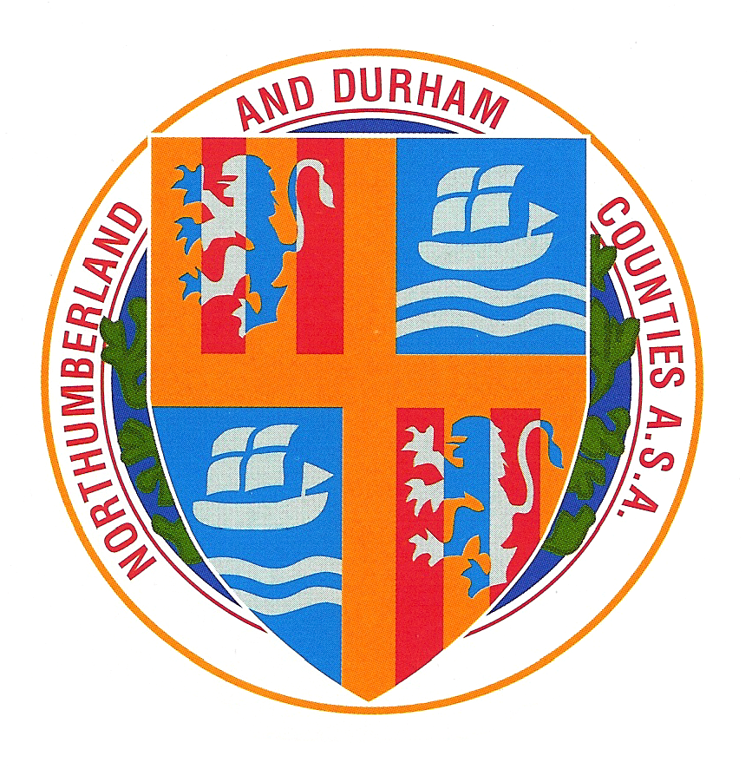
Northumberland & Durham Swimming
Association
2014 Championships
[under asa Laws & Technical rules]

Competing Age as on 9th March 2014

Sunderland Aquatic Centre, 1st and 2nd February 2014
Sunderland Aquatic Centre, 22nd/23rd February 2014
Sunderland Aquatic Centre, 8th/9th March 2014

1st and 2nd February 2014

 | Session 1  Saturday 1st February @ 09:00 |  | Session 2  Saturday 1st February @ TBC
 |  | Boys | 9/10yrs 4x50m Medley Team
Womens | 9 & Over 50m Freestyle | Girls | 11/12yrs 4 x 50m Freestyle Team
Mens | 9 & Over 50m Backstroke | Mens | Open 4x100m Medley Team
Womens | 9 & Over 50m Breaststroke | Boys | 9/10yrs 4x50m Freestyle Team
Mens | 9 & Over 50m Butterfly | Girls | 15/16yrs 4x50m Freestyle Team
 |  | Boys | 13/14yrs 4 x50m Medley Team
 |  | Girls | 11/12yrs 4x50m Medley Team
 |  | Womens | Open 4x100m Freestyle Team
 |  | Boys | 13/14yrs 4x50m Freestyle Team
 |  | Girls | 15/16yrs 4x50m Medley Team
 |  | Mens | Open 4x200m Freestyle Team
 | Finals of above |  | Finals of above

 | Session 3  Sunday 2nd February @ 09:00 |  | Session 4  Sunday 2nd February @ TBC
Womens | 9 & Over 50m Backstroke | Girls | 9/10yrs 4x50m Medley Team
Mens | 9 & Over 50m Freestyle | Boys | 11/12yrs 4x50m Freestyle Team
Womens | 9 & Over 50m Butterfly | Womens | Open 4x100m Medley Team
Mens | 9 & Over 50m Breaststroke | Girls | 9/10yrs 4x50m Freestyle Team
 |  | Boys | 15/16yrs 4x50m Freestyle Team
 |  | Boys | 11/12yrs 4x50m Medley Team
 |  | Girls | 13/14yrs 4x50m Freestyle Team
 |  | Mens | Open 4x100m Freestyle Team
 |  | Girls | 13/14yrs 4x50m Medley Team
 |  | Boys | 15/16yrs 4x50m Medley Team
 |  | Womens | Open 4x200m Freestyle Team
 | Finals of above |  | Finals of above

CLOSING DATE FOR ENTRIES: Wednesday 15th January 2014

Supported by: NESS Swimwear


Northumberland & Durham Swimming
Association
2014 Championships
[under asa Laws & Technical rules]

Competing Age as on 9th March 2014

Sunderland Aquatic Centre, 1st and 2nd February 2014
Sunderland Aquatic Centre, 22nd/23rd February 2014
Sunderland Aquatic Centre 8th/9th March 2014

Saturday 22nd & Sunday 23rd February 2014 - REVISED

 | Saturday 22nd February @ 09:00 |  | Saturday 22nd February pm @ TBC
Womens | 15&Over 400m freestyle HDW | Girls | 11/14yrs 200 I.M.
Girls | 10/14yrs 400m Freestyle HDW | Boys | 11/14yrs 100m Breaststroke
Boys | 11/14yrs 200 I.M. | Mens | Open 200m Breaststroke
Womens | Open 200 I.M. | Womens | Open 100m Butterfly
Mens | Open 200m Butterfly | Girls | 11/14yrs 100m Backstroke
Womens | Open 200m Breaststroke | Boys | 10/14yrs 400m Freestyle HDW
Girls | 9 /10yrs 200m Butterfly HDW | Mens | 15&Over 400m Freestyle HDW
Boys | 9/10yrs 200m Butterfly HDW
 | Finals of above |  | Finals of above

 | Sunday 23rd February @ 09:00 |  | Sunday 23rd February @ TBC
Girls | 10/14yrs 800m Freestyle HDW | Womens | Open 200m Butterfly
Womens | 15&Over 800m Freestyle HDW | Boys | 11/14yrs 200m Freestyle
Mens | 200 Open 200m Backstroke | Girls | 11/14yrs 200m Backstroke
Boys | 11/14yrs 100m Butterfly | Womens | Open 100m Breastroke
Girls | 11/14yrs 100m Freestyle | Boys | 9/10yrs 200 I.M. HDW
Mens | Open 200 I.M. | Girls | 9/10yrs 200m Freestyle HDW
Girls | 9/10yrs 200m Backstroke HDW
 |  |  | Finals of above
 | Finals of above

CLOSING DATE FOR ENTRIES: Wednesday 12th February 2014

Supported by: NESS Swimwear

Northumberland & Durham Swimming
Association
2014 Championships
[under asa Laws & Technical rules]

Competing Age as on 9th March 2014

Sunderland Aquatic Centre, 1st and 2nd February 2014
Sunderland Aquatic Centre, 22nd/23rd February 2014
Sunderland Aquatic Centre 8th/9th March 2014

Saturday 8th & Sunday 9th March 2014 - REVISED

 | Saturday 8th March @ 09:00 |  | Saturday 8th March @ TBC
Boys | 11/14yrs 200m Butterfly | Boys | 11/14yrs 100m Freestyle
Girls | 11/14yrs 200m Freestyle | Girls | 11/14yrs 100m Butterfly
Mens | Open 200m Freestyle | Boys | 9/10yrs 200m Backstroke HDW
Girls | 11/14yrs 200m Breaststroke | Mens | Open 100m Breaststroke
Mens | Open 100m Backstroke | Womens | Open 100m Freestyle
Womens | Open 200m Backstroke | Boys | 11/14yrs 200m Backstroke HDW
Boys | 10/14yrs 400m I.M. HDW | Girls | 10/14yrs 400m I.M. HDW
Mens | 15&Over400m I.M. HDW | Womens | 15&Over 400 mI.M. HDW
 | Finals of above |  | Finals of above

 | Sunday 9th March @ 09:00 |  | Sunday 9th March @ TBC
Boys | 10/14yrs 1500m Freestyle HDW | Womens | Open 100m Backstroke
Mens | 15& over 1500m Freestyle HDW | Mens | Open 100m Freestyle
Womens | Open 200m Freestyle | Girls | 11/14yrs 200m Butterfly
Girls | 11/14yrs 100m Breaststroke | Boys | 11/14yrs 200m Breaststroke
Boys | 11/14yrs 100m Backstroke | Girls | 9/10yrs 200m Breaststroke HDW
Mens | Open 100m Butterfly | Boys | 9/10yrs 200m Freestyle HDW
Boys | 9/10 yrs 200m Breaststroke HDW
Girls | 9/10yrs 200m I.M HDW
 | Finals of above |  | Finals of above

CLOSING DATE FOR ENTRIES: Wednesday 12th February 2014

Supported by: NESS Swimwear

