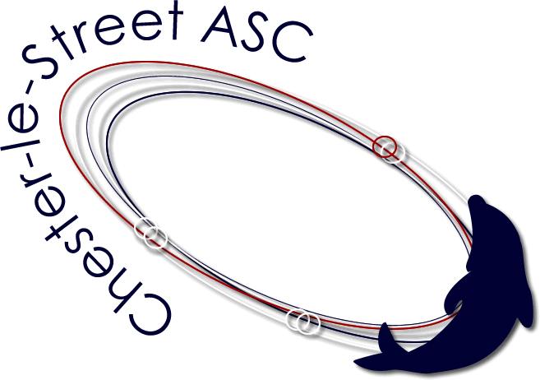
Chester-le-Street

Amateur Swimming Club
(Affiliated to Northumberland and Durham A.S.A.)

Club Headquarters:- The Burns Green Swimming Pool
Chester-le-Street Co Durham Tel (0191) 3886673
Chester Le Street Junior Gala 2013
Schedule of Events
(50m events will have finals)
Friday 25th October 2013
Session 1 Start 6.45pm (Warm Up 6.15pm)

Ev. 1 Boys 12/13/14 yrs 1500m Free
Ev. 2 Girls 10/11/12/13/14 yrs 800m Free
Saturday 26th October 2013 |  |  |  |  |  | Sunday 27th October 2013
Session 2 at 09:00 (Warm Up 8am) |  |  |  |  |  | Session 4 at 09:00 (Warm Up 8am)
Ev. 3 Girls |  | 09/10 years | 200m | Freestyle Team |  | Ev. 36 Boys | 09/10 years | 200m | Freestyle Team
Ev. 4 Boys |  | 9-12 years | 200m | Freestyle |  | Ev. 37 Girls | 9-12 years | 200m | Freestyle
Ev. 5 Girls |  | 9-12 years | 100m | Ind. Medley |  | Ev. 38 Boys | 9-12 years | 50m | Breaststroke
Ev. 6 Boys |  | 9-12 years | 50m | Backstroke |  | Ev. 39 Girls | 9-12 years | 50m | Breaststroke
Ev. 7 Girls |  | 9-12 years | 50m | Backstroke |  | Ev. 40 Boys | 9-12 years | 100m | Ind. Medley
Ev. 8 Boys |  | 9-12 years | 200m | Breaststroke |  | Ev. 41 Girls | 9-12 years | 200m | Backstroke
Finals:  Ev. 9 Girls |  | 9 years | 50m | Backstroke |  | Finals:  Ev. 42 Girls | 9 years | 50m | Breaststroke
Ev. 10 Girls  Ev. 11 Girls  Ev. 12 Girls  Ev. 13 Boys  Ev. 14 Boys  Ev. 15 Boys  Ev. 16 Boys |  | 10 years  11 years  12 years  9 years  10 years  11 years  12 years | 50m  50m  50m  50m  50m  50m  50m | Backstroke Backstroke Backstroke Backstroke Backstroke Backstroke Backstroke |  | Ev. 43 Girls  Ev. 44 Girls  Ev. 45 Girls  Ev. 46 Boys  Ev. 47 Boys  Ev. 48 Boys  Ev. 49 Boys | 10 years  11 years  12 years  9 years  10 years  11 years  12 years | 50m  50m  50m  50m  50m  50m  50m | Breaststroke Breaststroke Breaststroke Breaststroke Breaststroke Breaststroke Breaststroke
EV 17 & 18 Girls 9yrs & 10yrs Skins |  |  |  |  |  | Ev 50 & 51 Boys 9yrs & 10yrs Skins
Saturday 26th October 2013 |  |  |  |  |  | Sunday 27th October 2013
Session 3 at TBC |  |  |  |  |  | Session 5 at TBC
Ev. 19 Boys |  | 11/12 years | 200m | Freestyle Team |  | Ev. 52 Girls | 11/12 years | 200m | Freestyle Team
Ev. 20 Girls |  | 9-12 years | 50m | Butterfly |  | Ev. 53 Girls | 9-12 years | 200m | Butterfly
Ev. 21 Boys |  | 9-12 years | 200m | Butterfly |  | Ev. 54 Boys | 9-12 years | 50m | Freestyle
Ev. 22 Girls |  | 9-12 years | 200m | Breaststroke |  | Ev. 55 Girls | 9-12 years | 400m | Freestyle
Ev. 23 Boys |  | 9-12 years | 50m | Butterfly |  | Ev. 56 Boys | 9-12 years | 200m | Ind. Medley
Ev. 24 Girls |  | 9-12 years | 200m | Ind. Medley |  | Ev. 57 Girls | 9-12 years | 50m | Freestyle
Ev. 25 Boys |  | 9-12 years | 400m | Freestyle |  | Ev. 58 Boys | 9-12 years | 200m | Backstroke
Finals:  Ev. 26 Girls  Ev. 27 Girls  Ev. 28 Girls  Ev. 29 Girls  Ev. 30 Boys  Ev. 31 Boys  Ev. 32 Boys  Ev. 33 Boys |  | 9 years  10 years  11 years  12 years  9 years  10 years  11 years  12 years | 50m  50m  50m  50m  50m  50m  50m  50m | Butterfly  Butterfly  Butterfly  Butterfly  Butterfly  Butterfly  Butterfly  Butterfly |  | Finals:  Ev. 59 Girls  Ev. 60 Girls  Ev. 61 Girls  Ev. 62 Girls  Ev. 63 Boys  Ev. 64 Boys  Ev. 65 Boys  Ev. 66 Boys | 9 years  10 years  11 years  12 years  12 years  11 years  10 years  9 years | 50m  50m  50m  50m  50m  50m  50m  50m | Freestyle Freestyle  Freestyle  Freestyle  Freestyle  Freestyle  Freestyle  Freestyle
Ev 34 & 35 Girls 11yrs & 12yrs Skins |  |  |  |  |  | Ev 67 & 68 Boys 11yrs & 12yrs Skins

Chester le Street Junior Gala
BAGCATS
 | Boys |  | Girls
9 Years | Sprint | Best 50m | Sprint | Best 50m
9 Years | Form | Best 200m Form  Back, Breast, Fly | Form | Best 200m Form  Back, Breast, Fly
9 Years | Distance | Best 200m / 400m Free | Distance | Best 200m / 400m Free
9 Years | Ind.Medley | Best 100m / 200m IM | Ind.Medley | Best 100m / 200m IM
10 Years | Sprint | Best 50m | Sprint | Best 50m
10 Years | Form | Best 200m Form  Back, Breast, Fly | Form | Best 200m Form  Back, Breast, Fly
10 Years | Distance | Best 200m / 400m/800m Free | Distance | Best 200m / 400m/800m Free
10 Years | Ind.Medley | Best 100m / 200m IM | Ind.Medley | Best 100m / 200m IM
11 Years | Sprint | Best 50m | Sprint | Best 50m
11 Years | Form | Best 200m Form  Back, Breast, Fly | Form | Best 200m Form  Back, Breast, Fly
11 Years | Distance | Best 200m / 400m / 800m Free | Distance | Best 200m / 400m / 800m Free
11 Years | Ind.Medley | Best 100m / 200m IM | Ind.Medley | Best 100m / 200m IM
12 Years | Sprint | Best 50m | Sprint | Best 50m
12 Years | Form | Best 200m Form  Back, Breast, Fly | Form | Best 200m Form  Back, Breast, Fly
12 Years | Distance | Best 200m / 400m / 800m 1500m Free | Distance | Best 200m / 400m / 800m 1500m Free
12 Years | Ind.Medley | Best 100m / 200m IM | Ind.Medley | Best 100m / 200m IM

Age Groups.
The Age groups for the BAGCAT Competition are: 9 years 10 years, 11 years, 12 years,

Events.
Individual events as outlined in the Event schedule.
With the exception of the 50m events all events will be Heat Declared Winner.
The events will swim as multiple Age Groups the age on the day of each swimmer will appear on the programme, with each individual Age Group result being extracted from the overall results. The events will be seeded with reference to Entry Times.

