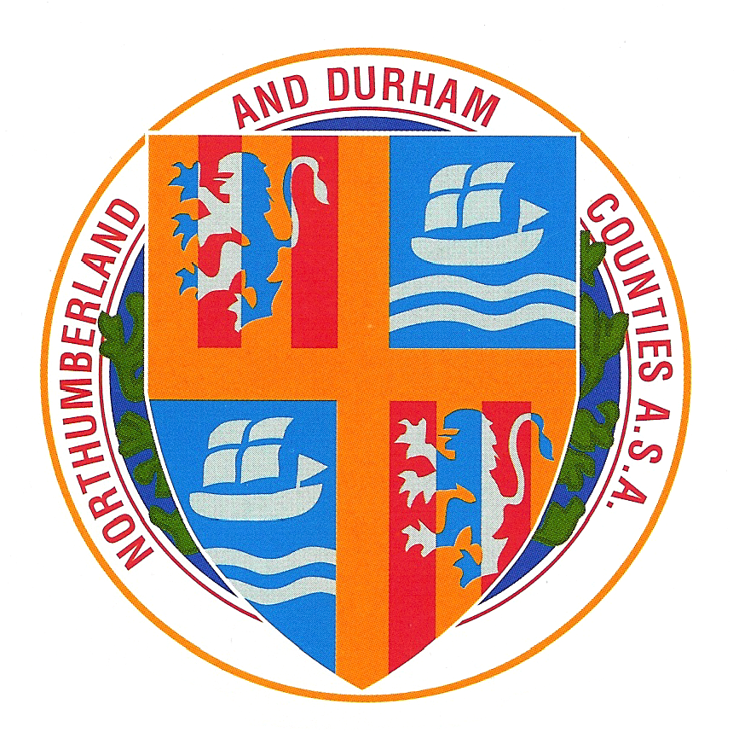
Northumberland & Durham Swimming
Association
2015 Championships
[under asa Laws & Technical rules]

Competing Age as at 31st December 2015

Sunderland Aquatic Centre, 7/8 February 2015
Sunderland Aquatic Centre, 28 February & 1st March 2015

 | Session 1  Saturday 7th February 2015 @ 09:00 |  | Session 2  Saturday 7th February 2015 @ TBC
Boys | 1500m Freestyle HDW | Boys | Open 4 x 100m Freestyle Team
Girls | 50m Freestyle
Boys | 100m Breaststroke | Girls | 400m I.M. HDW
Girls | 200m Freestyle HDW | Boys | 50m Backstroke
 |  | Girls | 100m Backstroke
Boys | Open 4 x 200m Freestyle Team | Boys | 200m Butterfly HDW
 | FINALS |  | FINALS
Girls | 10/11,12,13,14,15 & 16/Over 50m Freestyle | Girls | 10/11,12,13,14,15 & 16/Over 50m Backstroke
Boys | 10/11,12,13,14,15 & 16/Over 100m Breaststroke | Boys | 10/11,12,13,14, 15 &16/Over 100m Backstroke

 | Session 3  Sunday 8th February 2015 @ 09:00 |  | Session 4  Sunday 8th February 2015 @ TBC
Girls | 800m Freestyle HDW | Girls | Open 4 x 100m Freestyle Team
Boys | 50m Freestyle
Girls | 100m Breaststroke | Boys | 400m I.M. HDW
Boys | 200m Freestyle HDW | Girls | 50m Backstroke
 |  | Boys | 100m Backstroke
Girls | Open 4 x 200m Freestyle Team | Girls | 200m Butterfly HDW
 | FINALS |  | FINALS
Boys | 10/11,12,13,14,15 & 16/Over 50m Freestyle | Boys | 10/11,12,13,14,15 & 16/Over 50m Backstroke
Girls | 10/11,12,13,14,15 & 16/Over 100m Breaststroke | Girls | 10/11,12,13,14,15 & 16/Over 100m Backstroke

Supported by: NESS Swimwear


Northumberland & Durham Swimming
Association
2015 Championships
[under asa Laws & Technical rules]

Competing Age as at 31st December 2015

Sunderland Aquatic Centre, 7/8th February 2015
Sunderland Aquatic Centre, 28th February/1st March 2015

 | Session 5  Saturday 28th February 2015 @ 09:00hrs |  | Session 6  Saturday 28th February 2015 @ TBC
Girls | 400m Freestyle HDW | Boys | 200m I.M. HDW
Boys | 100m freestyle | Girls | 100m Butterfly
Girls | 50m Breaststroke | Boys | 50m Butterfly
Boys | 200m Backstroke HDW | Girls | 200m Breaststroke HDW
Girls | Open 4 x 100m Medley Team
 | FINALS |  | FINALS
Boys | 10/11,12,13,14,15 & 16/Over 100m Freestyle | Boys | 10/11,12,13,14,15 & 16/Over 50m Butterfly
Girls | 10/11,12,13,14,15 & 16/Over 50m Breaststroke | Girls | 10/11,12,13,14,15 & 16/Over 100m Butterfly

 | Session 7  Sunday 1st March 2015 @09:00hrs |  | Session 8  Sunday 1st March 2015 @ TBC
Boys | 400m Freestyle HDW | Girls | 200m I.M. HDW
Girls | 100m Freestyle | Boys | 100m Butterfly
Boys | 50m Breaststroke | Girls | 50m Butterfly
Girls | 200m Backstroke HDW | Boys | 200m Breaststroke HDW
Boys | Open 4 x 100m Medley Team
 | FINALS |  | FINALS
Girls | 10/11,12,13,14,15 & 16/Over 100m Freestyle | Girls | 10/11,12,13,14,15 & 16/Over 50m Butterfly
Boys | 10/11,12,13,14,15 & 16/Over 50m Breaststroke | Boys | 10/11,12,13,14,15 & 16/Over 100m Butterfly

Individual Entry Fee is £6.50 for Entries received by 28 January 2015 at 12 noon
Individual Entry Fee for Entries received during the period 29 January – 25 February
is £10:00

Supported by: NESS Swimwear

