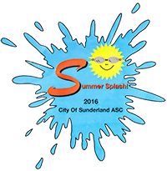**City of Sunderland - Admission Prices**

**Summer Splash 2016**

£4

**Program**

**List**

**Session Pass**

Saturday AM Red

Saturday PM Purple

Sunday AM Blue

Sunday PM Yellow

**Start**

**List**

£2

50p

**Weekend Pass**

2 x WristBand (Pink

&Green)

)

£14

Children (under 18) accompanied by adults free

OAP half price (admission only)

**Wrist bands to be worn at all times!**

20p

**Results Sheet**

£8

**Day Pass**

Saturday Pink

Sunday Green