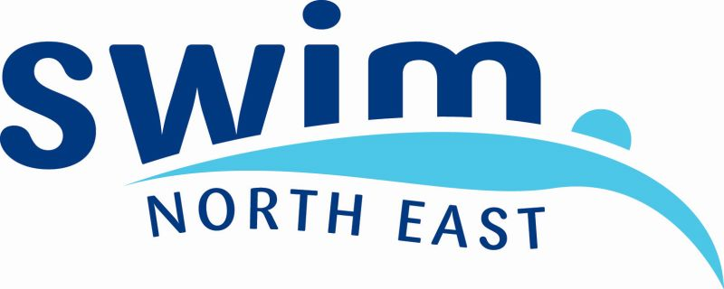

ASA North East Region
Para-Swimming Swimming Championships 2015

Event Information Pack

Run under ASA Rules –
(ASA have adopted the IPC Swimming Rules)

Location: The Hydro, Jennyfield Drive, Harrogate, HG1 2RP

Date: 26th September 2015

Registration: 2:00pm

Warm-Up: 2:30pm

Competition start: 3:30pm

Forms must be returned to:
David Dickenson
56 Quarry Lane
Sheffield
South Yorkshire
S11 9EB

Tel: 0114 2815488 Email: ddickenson@yahoo.com

No entries will be accepted after: 11th September 2015

Swimmers requiring classification must enter before: 13th August 2015

Cheques payable to: ASA North East Region

Conditions
Classification
This competition is open to current Category 2 ASA/WASA/SASA members with a swimming classification S1-15.
Guest entries will only be accepted from:
- Swimmers on the Physical Classification waiting list (classification 99)
- Swimmers with an INAS or UKSA classification application submitted.

A physical classification team will be present at the championships; Physical classifications appointments will be held on the morning of the 26th September. Those swimmers selected for classification will be contacted prior to the event.

If anyone requires any assistance in the area of classification please contact Carolyn Wade at the British Para-Swimming Office on 01612445332 or email classification@swimming.org

Swimmers from outside the host Region
Swimmers from outside the North East region are welcome to enter this event but should entries exceed the capacity of the pool, entries from the North East Region will be prioritised.

Events
Individual events will be made up of swimmers with similar entry times, irrespective of their age or disability. This is in order to make the events more competitive and increases the opportunity for swimmers to gain fast times. It is important therefore that accurate times are submitted for all events. If no time is completed, then the swimmer will be placed in the slowest grouping. Subject to entries, the promoter reserves the right to alter session timings and to swim events of mixed gender together, if this is to the benefit of the competition

Epilepsy
Swimmers with epilepsy should ensure that the lifeguards are made aware of this before each of their races.
A responsible adult who knows the swimmers condition should accompany them. This person must act as a “spotter” on the poolside while the swimmer is in the water.

Refreshments It is advised that athletes bring their own food and drinks. Drinks will be made available for officials.

Medals
Medals will be awarded to the first three places in each event for male and female, using British Para-Swimming Points (S1-14). Separate medals will be awarded to S15 swimmers.
The minus 1 rule will be used to award medals:
- where there are only three swimmers in an event, only the top two placed swimmers will receive medals
- where there are two swimmers, only the winner will receive a medal
- where there is only one swimmer, they will receive a medal if they swim faster than their entry time

Pool side Access
Only team managers, coaches and escorts that have pool side passes will have access to the poolside. Classes S1-5 and S11 are eligible for free escort passes to gain access to poolside, to give assistance to swimmers. Passes should be requested at the time of entry at £5 per pass and can be collected on the day of competition.

Entry fees
There will be a £6 entry fee per event. The Entry fee should be paid when submitting the entry form.
Cheques made payable to ASA North East Region.

Event Photography
Within the guidelines of the ASA Child Protection Policy, anyone wishing to use a Video Camera and/or a Stills Camera during any part of this event, including the Warm up period, must complete the Photography Registration Form upon your arrival. Failure to do this will lead to the Camera operator being asked to leave the event.

Relay Teams
Clubs wishing to enter a relay team should indicate this on the entry form before the closing date. Additional relay team entries will not be accepted after this date. The event organisers reserve the right to withdraw undersubscribed relay events following the closing date

Event Timetable
2:00pm Registration
2:30pm Warm up
3:30pm Competition

100m Freestyle
50m Breaststroke
100m Backstroke
400m Freestyle
50m Backstroke
100m Individual Medley
Break
200m Freestyle
100m Butterfly
150m Individual Medley (SM1-4 only)
100m Breaststroke
50m Butterfly
200m Individual Medley
50m Freestyle
4x 50m Freestyle relay
Entry Checklist
Swimmers:
- I am an ASA/WASA /SASA member

- I hold a British Or IPC Classification S1-14
OR
I have a current UK Deaf Sport S15 classification
OR
I am currently on the waiting list for Physical Classification
OR
I have submitted my completed application/paperwork with UKSA/INAS

- I have completed the entry form

- I have enclosed a cheque payable to ‘ASA North East Region’

Photography By entering the North East Regional Para-Swimming Championships, swimmers are giving consent to photographs being taken of them during the championships by the organisers or registered photographers.
If you DO NOT give your photographic consent, please tick here and return with your entry form.

Escorts / Coaches / Team managers:

- I have completed the Application for a Poolside Pass

- I have enclosed a cheque payable to “ASA North East Region”

The organisers reserve the right to reject incomplete or late entry forms and those with no payment.

The closing date for entries is 11th September

Those wishing to be considered for classification should enter before 13th August

David Dickenson, 56 Quarry Lane, Sheffield, South Yorkshire, S11 9EB

- Entry Form
ASA North East Disability Swimming Championships
Please type or print clearly
First Name |  | Surname
Date of Birth |  | Sex | Male/Female
Address
Region/Country
Tel. Home |  | Tel. Mobile
Email
Club

Classification
S |  | SB |  | SM |  | W/L

ASA/SASA/WASA Registration Number
UKSA/INAS Reg No (or date of application)
All S14 swimmers need to be registered with UKSA or INAS-FID at the time of entry or have made an application in the last 12 months

Please indicate which events you wish to enter by submitting times next to the appropriate events.
Events Available | Time Achieved
50m Freestyle
100m Freestyle
200m Freestyle
400m Freestyle
50m Backstroke
100m Backstroke
50m Butterfly
100m Butterfly
50m Breaststroke
100m Breaststroke
100m Individual Medley
150m Individual Medley (SM1-4 only)
200m Individual Medley

I confirm I am a Category 2 member of one of the associations above. I accept the terms, conditions and code of conduct for the event.

Signature |  | Date
To be signed by the parent/guardian of any competitor under the age of 18 years

Relays- Please indicate the number of teams your club wish to enter in the mixed relays

Club |  | Number of teams

Application for Poolside Pass
ASANER Para-Swimming Championships 2015

Team staff requiring access to the pool-side at the ASANER Para-Swimming Championships are required to be in possession of a pass issued by the ASANER

The ASANER requires that team staff with access to the pool-side have been registered under the ASA Child Protection Procedures and have attended a Team Managers Training Course.

These passes will only be valid for the ASANER Para-Swimming Championships 2015.

Passes to be collected from the recorders at the event.

2015 passes £5 per pass

Cheques payable to ASA North East Region

Club /
Applicant

Number of passes @ £5.00 |  | Total

If accompanying a swimmer S1-5 or S11 please indicate so here

Return completed form to:

David Dickenson, 56 Quarry Lane, Sheffield,
South Yorkshire, S11 9EB

Tel: 01142815488
Email: ddickenson@yahoo.com

