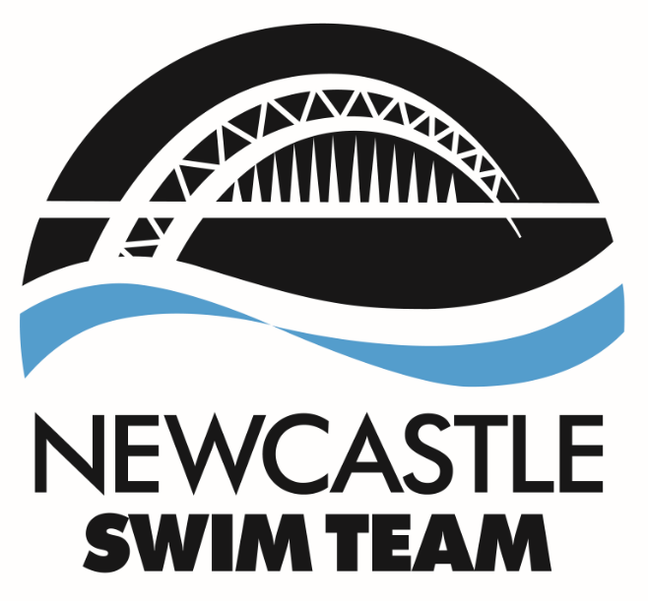
INVITATIONAL SHRIMP GALA
Sunderland Aquatic Centre
SUNDAY 3rd OCTOBER 2021

PROGRAMME OF EVENTS

Session 1 – Boys/Girls 8 & 9 and Girls 10 years
Warm up: 8:00am
 | Girls | 8 - 10 years | 50m | Breaststroke
 | Boys  Girls  Girls  Boys  Girls  Boys  Girls  Girls  Boys | 8 - 9 years  8 – 9 years  10 years  8 – 9 years  8 – 10 years  8 – 9 years  10-15 min break  8 – 9 years  10 years  8 – 9 years | 50m  100m  200m  100m  50m  50m  100m  200m  100m | Backstroke  Freestyle  Freestyle  Freestyle  Butterfly  Butterfly  Individual Medley  Individual Medley  Individual Medley
 | Girls  Boys  Girls | 8 - 10 years  8 – 9 years  8 – 10 years | 50m  50m  50m | Backstroke  Breaststroke  Freestyle
 | Boys | 8 - 9 years | 50m | Freestyle
Session 2 Boys 10,11,12 & Girls 11,12
Warm up: Provisionally 1pm

 | Girls | 11 - 12 years | 200m | Freestyle
 | Boys | 10 - 12 years | 50m | Backstroke
 | Girls | 11 - 12 years | 50m | Breaststroke
 | Boys  Girls  Boys  Girls  Boys  Girls  Boys  Girls  Boys | 10 - 12 years  11 - 12 years  10 – 12 years  10-15 min break  11 – 12 years  10 – 12 years  11 – 12 years  10 – 12 years  11 – 12 years  11 – 12 years | 200m  50m  50m  200m  50m  50m  200m  50m  50m | Freestyle  Butterfly  Butterfly  Individual Medley  Breaststroke  Backstroke  Individual Medley  Freestyle  Freestyle

closing date for entries: Monday 27th September 2021 12 Noon

Entry Fee: £6.50 per swim

All Events HDW(Heat Declared Winner)basis
Age Groups (Boys & Girls) are 8yrs, 9yrs, 10yrs, 11yrs, 12yrs
(Age as at 3rd October 2021).
Entry file available from: admin@newcastleswimteam.co.uk

INVITATIONAL SHRIMP GALA
Sunderland Aquatic Centre
SUNDAY 3rd October 2021

UPPER LIMITS
MALE UPPER LIMITS |  |  |  |  |  |  |  | FEMALE UPPER LIMITS
8 Years | 9 Years | 10 Years | 11 Years | 12 Years | Events |  | 8 Years |  |  | 9 Years | 10 Years | 11 Years |  | 12 Years
Open | Open | 32.30 | 31.10 | 30.00 | 50 Free |  | Open |  |  | Open | 32.10 | 30.50 |  | 30.00
Open | Open |  |  |  | 100 Free |  | Open |  |  | Open
 |  | 2.34.00 | 2.24.00 | 2.20.00 | 200 Free |  |  |  |  |  | 2.33.00 | 2.24.00 |  | 2.20.00
Open | Open | 37.00 | 35.00 | 34.00 | 50 Back |  | Open |  |  | Open | 36.50 | 35.00 |  | 34.00
Open | Open | 43.50 | 40.50 | 40.00 | 50 Breast |  | Open |  |  | Open | 42.00 | 39.50 |  | 38.50
Open | Open | 37.00 | 35.00 | 33.50 | 50 Fly |  | Open |  |  | Open | 36.00 | 33.00 |  | 32.00
Open | Open |  |  |  | 100 IM |  | Open |  |  | Open
 |  | 2.54.00 | 2.42.00 | 2.38.00 | 200 IM |  |  |  |  |  | 2.51.00 | 2.42.00 |  | 2.35.00

Invitational Shrimp Gala
SUNDAY 3rd October 2021
Sunderland Aquatic Centre

- The meet will be swum under ASA Laws and Technical Rules and will be as a [Level 4].

- The pool length will be 25m of variable depth with 10 lanes & anti-wave lane ropes; a separate swim down facility is available. It is the responsibility of coaches to ensure that the swim facility is used correctly – in the event that it is not, the pool will be closed.

- Electronic Timing will be in operation with scoreboard display. Times and places shown on the electronic scoreboard are for information only, and are not necessarily the official result.

- Events will be all strokes 50m plus 100 Freestyle (8,9y) 100IM (8,9y), 200IM (10,11, 12), 200 Freestyle (10,11, 12). All events will be HDW. (Heat Declared Winner)

- Entries will be accepted from rankings and training times. If there is no time entered then the swimmer will be rejected from the event.

- Upper limit times will apply. Swimmers must not have swam faster than the upper time limit and any swimmers entered on times above the upper time for their age and event will be excluded. All entry times must be converted to 25m pool times by use of the ASA Conversion tables. Entries may be limited to comply with session limits. Should the meet be oversubscribed, entries will be rejected on the basis of fastest submitted times in each age group.

- Age Groups are 8 yrs, 9 yrs,10 yrs, 11yrs, 12 yrs Age as at 3rd October 2021.

- Medals will be issued to the first six places in age groups 8, 9, 10, 11 and 12 in events as listed above.
.
- Poolside entries will not be accepted.

- Entry Fees £6.50 per swim
Coaches passes £10.00

- BACS payments should be paid to HSBC S/C: 40 37 37 A/C No. 51446959 Reference Shrimp Oct 21

- Entries should be submitted via sportsystems or entry form and should be e-mailed to Julie Row on admin@newcastleswimteam.co.uk

- Seeded heat start lists will be produced prior to the start of the meet. Any withdrawal should be notified to Julie Row – admin@newcastleswimteam.co.uk by 5pm on Friday 1st October 2021.

- Coaches/Team Managers are responsible for ensuring competitors report to the marshalling area at the required time. Failure to report to marshalling in good time may result in elimination from the event.

- For safety reasons only swimmers who can perform an ASA competitive start may perform a shallow racing dive from the starting blocks. Where appropriate, over the top starts will be used during the meet. Swimmers are requested to remain in the water until asked to leave the pool.

- Access to pool-side will be restricted to swimmers, coaches, officials and authorised helpers in line with Swim England Child Protection Policy.

- To comply with the Data Protection Act you agree that we may publish your personal information as part of the results of the event and may pass such information to the governing body or any affiliated organisation for the purpose of insurance, licenses or for publishing results either for the event alone or combined with or compare to other events. Results may include (but not limited to) name, any club affiliation, race times, age category.

Invitational Shrimp Gala
SUNDAY 3rd October 2021
Sunderland Aquatic Centre

- The use of any photographic equipment (still, video or digital including mobile phones with photo facilities) by members of the public is strictly prohibited by Sunderland Council.

- The Lead Referee for this event will be: Kevin Rand. The referee’s decision is final

- Admission for spectators will be £10 to include start lists and a raffle ticket.

- A swimwear supplier may display over the weekend.

- These conditions are subject to government guidance for Covid19 at the time of the event and may be subject to change at short notice

- All spectators must scan into the facility through the track and trace QR code or give names and contact number for track and trace.

- Spectator numbers may be limited to adhere to Sunderland Aquatic Centres maximum centre numbers. In the event that spectators are limited this will be on a 1 adult per swimmer basis.

Any points not covered above will be at the discretion of the meet manager.

Invitational Shrimp Gala
SUNDAY 3rd October 2021
Sunderland Aquatic Centre

SUMMARY OF ENTRIES

CLUB ___________________________

CONTACT NAME ___________________________

ADDRESS ___________________________

___________________________

___________________________

TEL NO ___________________________

E-MAIL ___________________________

Female Entries _____ @ £6.50 £ ____________

Male Entries _____ @ £6.50 £ ____________

Coaches Pass _____ @ £10.00 £ ____________

Total Entry Fee Enclosed £ ____________

Closing date for entries: Monday 27th September 12 NOON

Please email this sheet along with your entries to:
admin@newcastleswimteam.co.uk

Bank Details:- HSBC S/C: 40 37 37 A/C No. 51446959 Reference Shrimp Meet Oct 21

